# Practical No: 01

**Aim:** Configuring WEP on a Wireless Router

**Components:** Wireless Router, Router, Switch, Device (PC)

**Theory:** Wired Equivalent Privacy (WEP) is a security protocol, specified in the IEEE Wireless Fidelity (Wi-Fi) standard, 802.11b. That standard is designed to provide a wireless local area network (WLAN) with a level of security and privacy comparable to what is usually expected of a wired LAN.

**Cisco Packet Tracer Setup:- Implementation:**

**Step 1:** Creating connections using Ethernet and serial cable between devices

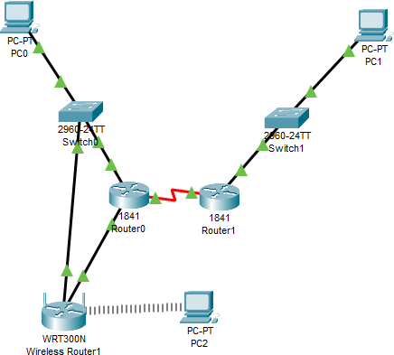

**Step 2:** Configuring all devices according to the table below

|  |  |  |  |
| --- | --- | --- | --- |
| Device | Interface | IPv4 address | Other |
| PC0 | IP configuration in  desktop | 192.168.1.2 | Default Gateway:  192.168.1.1 |
| PC1 | IP configuration in  desktop | 192.168.2.2 | Default Gateway:  192.168.2.1 |
| Router0 | FastEthernet0/0 | 192.168.1.1 |  |
| Router0 | FastEthernet0/1 | 20.0.0.1 |  |
| Router0 | Serial0/0/0 | 10.0.0.1 | Clock rate: 64000 |
| Router1 | FastEthernet0/0 | 192.168.2.1 |  |
| Router1 | Serial0/0/0 | 10.0.0.2 | Clock rate: 64000 |
| PC2 | IP Config in desktop |  | Set to DHCP |

**Step 3:** Configuring wireless router

# Click on wireless router > GUI and set the address

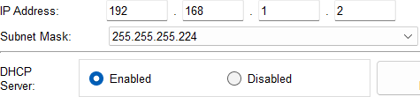

**Step 4:** Adding security mode as **WEP** and setting up key as **2a2a2a2a2a**

**Output:**

